Title
Given name Family name
Affiliation

abstract (less than 500 chracters)
First paragraph
Second paragraph
Etc.
Keywords: (1st par)

1. Introduction (heading1)

2. further Clause

references

Acknowledgements

Corresponding Author Name:
Affiliation:
e-mail:

Styles
The following section shows all the styles by using sample lines. Whenever you click to a line, the name of the style appears in the drop down list.

title (Arial 14 bold, all capital, 12 points space after)
author

heading 1 (Arial 10 bold, all capital, 6 points space before and after)

Heading2 (Arial 10 bold, 6 points space before and after)

Heading3 (Arial 10 italic, 6 points space before and after)

Heading4 (Arial 10, 6 points space before and after)
This is the first paragraph after any heading. The short cut key of “Alt 1” is assigned. (Arial 10, 6 points space after)
This is any other paragraph. The short cut key of “Alt n” is assigned. (Arial 10, first line indent 0,5 cm (0,2“), 6 points space after)
- Numbered bulleted list (Arial 10)
- Bulleted list (Arial 10)

The next line shows an example of the equation style: (Arial 10, indentation 0,5 cm (0,2“))
(1)
header (Arial 9), ex) Figure 1. nnnnn (centered location below figures)

footer (Arial 9), ex) Table 1. nnnnn (centered location over tables)

Note x: text of the note nnnnnnnnnnnnnnnnnnnnnnnnnnnnnnnnnnnnnnnnnnnnn (Arial 10, hanging indent 1,25 cm (0,5“))
Last note: text of the note nnnnnnnnnnnnnnnnnnnnnnnnnnnnnnnnnnnnnnnnnnnnnnn (Arial 10, hanging indent 1,25 cm (0,5“), 6 points space after)
1 page number (Arial 10)
address (Arial 9)

sample

View direction-dependent visual comfort in office with 3 façade types

Erxiao Wang¹, Xiaoming Li²
（1.School of Architecture, Tsinghua University, Beijing, China; 2. School of Architecture,Tianjin University, Tianjin, China）

ABSTRACT
Glare is position and view direction-dependent within a space, now most visual comfort analysis is taken place in a fixed position and view direction. In fact, - - - - - - - - - - - - - - - -
To study this issue, an office room with three façade types are studied in this paper. - - - - - - - - - - - - - -.
Keywords: visual comfort, discomfort glare, daylighting, view direction

1. INFORMATION
A good distribution of daylight may create a more pleasant office environment and improve the productivity and well-being of the occupants [1]. A survey showed that a variety of non-standardized daylight prediction methods– primarily rules of thumb – are currently being widely used [2]. - - - - - - - - - - -

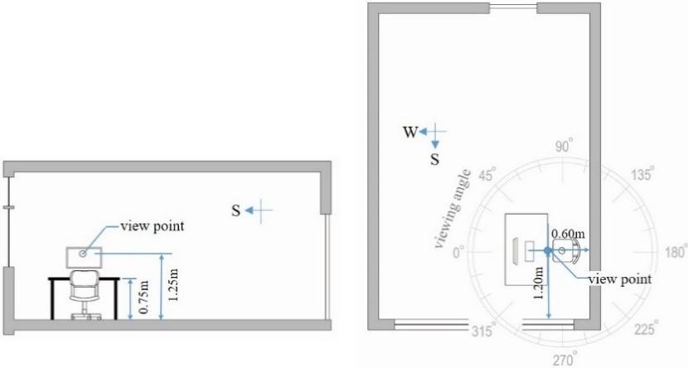
Figure 1. Geometric properties in section and plan of the model office

2. METHODOLOGY
2.1 Concept
- - - - - - - -

Figure x. nnnnnnnnnnnnnn

2.2 Schematic design

Figure x. nnnnnnnnnnnnnn

2.3 Design development

Figure x. nnnnnnnnnnnnnn

The target luminance values for each facade component are summarized in Table 1.

Table 1. Target luminance values

REFERENCE
- CIBSE, "Energy Efficiency in Buildings," CIBSE Guide F, The Chartered Institution of Building Services Engineers, 2004.
- Anca D. Galasiu, Christoph F. Reinhart. Current daylighting design practice: a survey[J]. Building Research & Information, 2008, 36(2):159-174.

ACKNOWLEDGEMENT

The work was supported by the Open Project of State Key Laboratory of Green Building in Western China（xxxx）.- - - - - - - - - - -

Corresponding Author: Erxiao Wang
Affiliation: School of Architecture, Tsinghua University
e-mail: erxiao@163.com

