Title
Given name Family name
Affiliation

abstract (less than 500 chracters)
First paragraph
Second paragraph
Etc.
Keywords: (1st par)

1. Introduction (heading1)

2. further Clause

references

Acknowledgements

Corresponding Author Name:
Affiliation:
e-mail:

Styles
The following section shows all the styles by using sample lines. Whenever you click to a line, the name of the style appears in the drop down list.

title (Arial 14 bold, all capital, 12 points space after)
author

heading 1 (Arial 10 bold, all capital, 6 points space before and after)

Heading2 (Arial 10 bold, 6 points space before and after)

Heading3 (Arial 10 italic, 6 points space before and after)

Heading4 (Arial 10, 6 points space before and after)
This is the first paragraph after any heading. The short cut key of “Alt 1” is assigned. (Arial 10, 6 points space after)
This is any other paragraph. The short cut key of “Alt n” is assigned. (Arial 10, first line indent 0,5 cm (0,2“), 6 points space after)
- Numbered bulleted list (Arial 10)
- Bulleted list (Arial 10)

The next line shows an example of the equation style: (Arial 10, indentation 0,5 cm (0,2“))
(1)
header (Arial 9), ex) Figure 1. nnnnn (centered location below figures)
footer (Arial 9), ex) Table 1. nnnnn (centered location over tables)

Note x: text of the note nnnnnnnnnnnnnnnnnnnnnnnnnnnnnnnnnnnnnnnnnnnnn (Arial 10, hanging indent 1,25 cm (0,5“))
Last note: text of the note nnnnnnnnnnnnnnnnnnnnnnnnnnnnnnnnnnnnnnnnnnnnnnn (Arial 10, hanging indent 1,25 cm (0,5“), 6 points space after)
1 page number (Arial 10)
address (Arial 9)

sample

EFFECT OF WORKPLACE POSITIONS ON HUMAN’S ALERTNESS, MOOD AND VISUAL SATISFACTION: A FULL-SCALE EXPERIMENT IN BEIJING
Erxiao Wang, Xiaoming Li
（School of Architecture, Tsinghua University, Beijing, China）

ABSTRACT
This study introduces a human experiment research on participants' alertness, mood, and self-reported visual satisfaction. The experiment was conducted in a spring period(19th Apr 2019-19th May 2019) in a office building designed to provide daylight availability in Beijing, China. The research methods used included lighting measurements, KSS (Karolinska Sleepiness Scale) sleepiness evaluation, PANAS (Positive and Negative Affect Schedule)mood survey, and self-reported questionnaires. Key findings are as follows: Within a certain illuminance range, the proportion of daylight to artificial light has a little but significant effect on human‘s negative mood level; Within a certain illuminance range, neither the illuminance nor the proportion of daylight have a effect on human’s alertness and positive mood level.
Keywords: Proportion of daylight to artificial light, Alertness and mood, Visual satisfaction, Workplace, Beijing

1. INTRODUCTION
Light environment has been recognized as one of the key factors which have an effect on people’s alertness, mood and visual satisfaction[1-2]. Nowadays a lot of people work and live in workplace for long time, and researches about light environment in workplace get more attention[3-4].A research in US[5] showed that there is more daylight exposure in summer than in winter, and participants’ sleep quantity and quality are better. A study in Canada[6] showed that light exposure with illuminance above 1000lx is associated with positive social activities and mood. Another study[7] found that providing workers with more light exposure with high level illuminance in winter helps improving workers’ mood. A research in China[8].
- - - - - - - - - - - - -

2. METHODS
2.1 Site
- - - - - - - - - - - - -
- - - - - - - - - - - - -
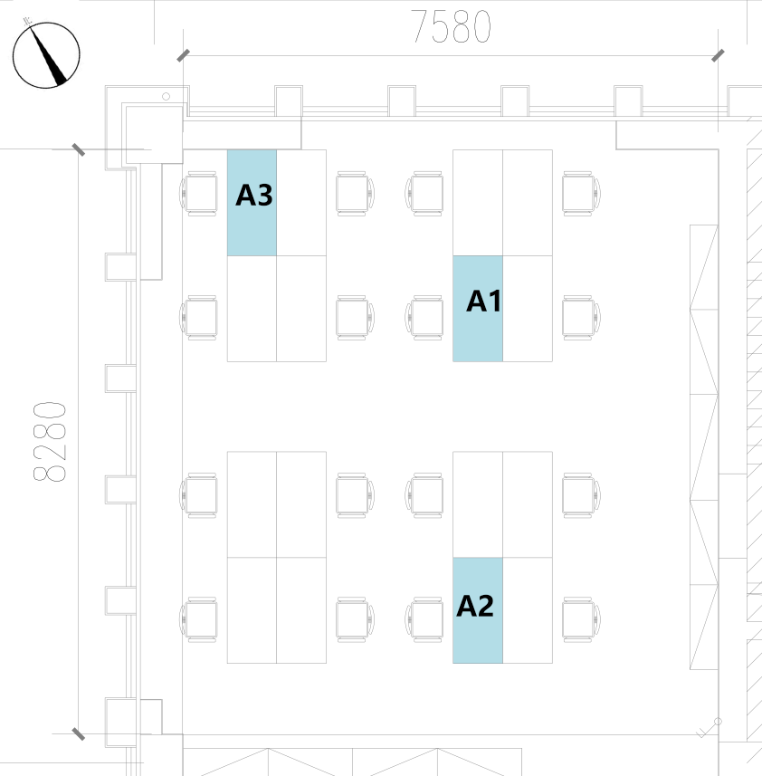
Figure x. Room B positions

Table 1. Target luminance values

3. CONCLUSION
- - - - - - - - - - - - -

REFERENCE
- Smolders, K. C. H. J., De Kort, Y. A. W., & van den Berg, S. M. Daytime light exposure and feelings of vitality: Results of a field study during regular weekdays. Journal of Environmental Psychology, 2013, 36, 270-279.
- Boubekri, M., Cheung, I. N., Reid, K. J., Wang, C. H., & Zee, P. C. Impact of windows and daylight exposure on overall health and sleep quality of office workers: a case-control pilot study. Journal of clinical sleep medicine, 2014,10(06), 603-611.

- - - - - - - - - - - - -

ACKNOWLEDGEMENT

Corresponding Author: erxiao Wang
Affiliation: School of Architecture, Tsinghua University
e-mail : erxiao@163.com

